|  |
| --- |
| User Manual  Leave & Attendance Management (Employee) |
| REFERENCE: GW/ERP/USER MANUAL |
|  |
| **Genweb2 Ltd.** |
| **31-Jul-17** |



|  |
| --- |
|  |

Contents

1. User Login 3

1.1 Home Page 3

1.2 Login Page 3

1.3 Log out Page 4

1.4 Edit Profile and Change Password 4

1.5 Website Browse and Back to Home Page 6

2. Leave Request 7

2.1 Create Leave Request 7

2.2 Show Leave Summary 9

2.3 Create Leave Allocation Request 10

3. Short Leave Request 11

2.1 Create Short Leave Request 11

4. Attendance 13

4.1 Create Manual Attendance 13

4.2 Create Alter Rostering 15

5. OT Requisition 17

4.1 Create a OT Request 17

# 1. User Login

## 1.1 Home Page

For user login we have to go website home page by using URL: “**http://202.164.208.130:8069**”. Click sign in button and find out login page.

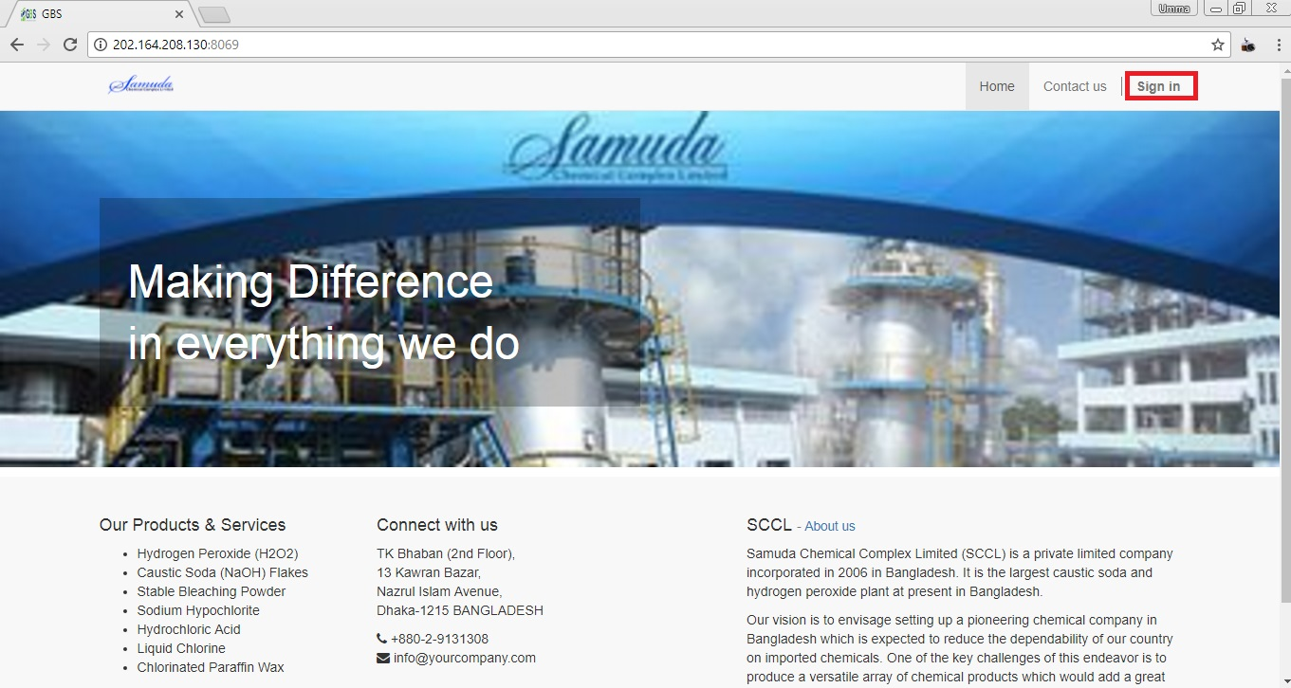

Fig: Home Page

## 1.2 Login Page

After click on sign in button, fill Email and Password -> Click **Log in** button.

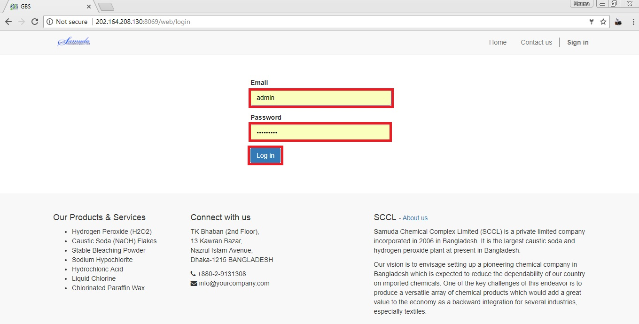

Fig: Login Page

## 1.3 Log out Page

If we want to sign out from website then click **User icon** then find out **Log out** button and click.

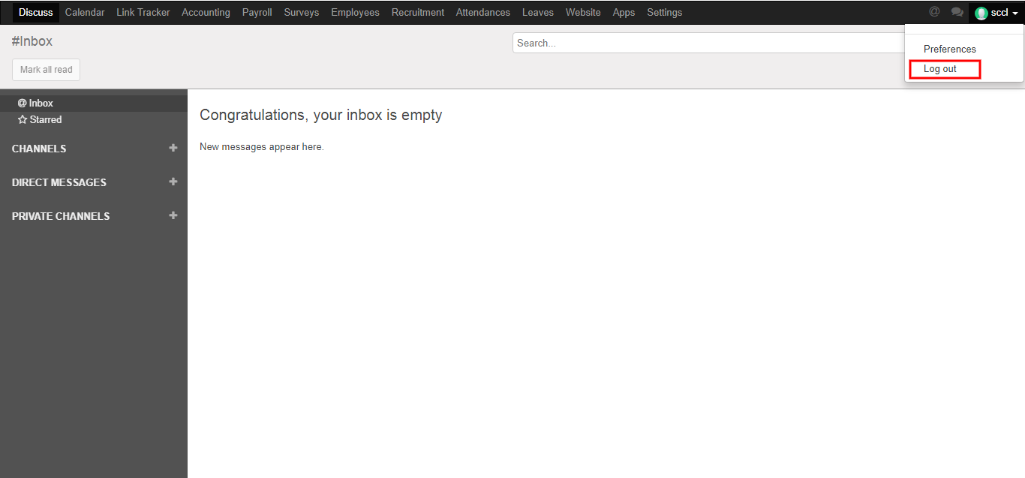

Fig: Logout Page

## 1.4 Edit Profile and Change Password

First we need to click **Preferences** then edit our profile and change our password. After entering the all information click **Save**.

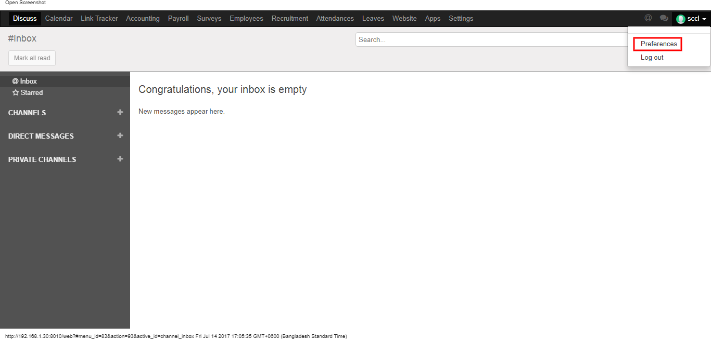

Here we can edit our information what we want. After entering the all information click **Save**.

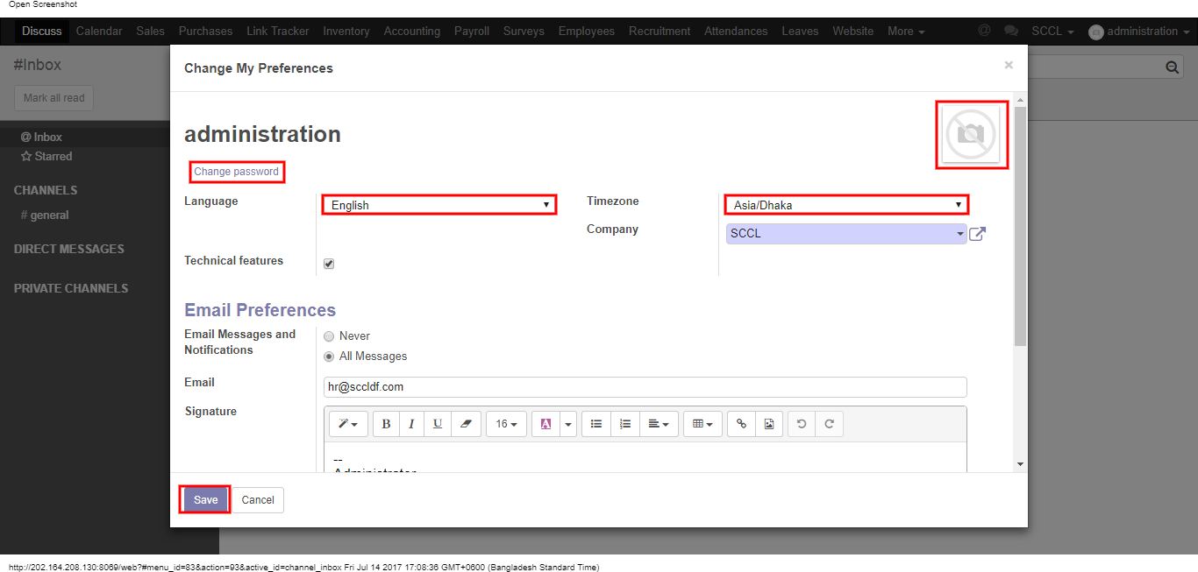

Figure: Edit Profile

Here we can change our own password. First we have to enter our Old Password then enter New Password & Confirm New Password. After entering the information click **Save**.

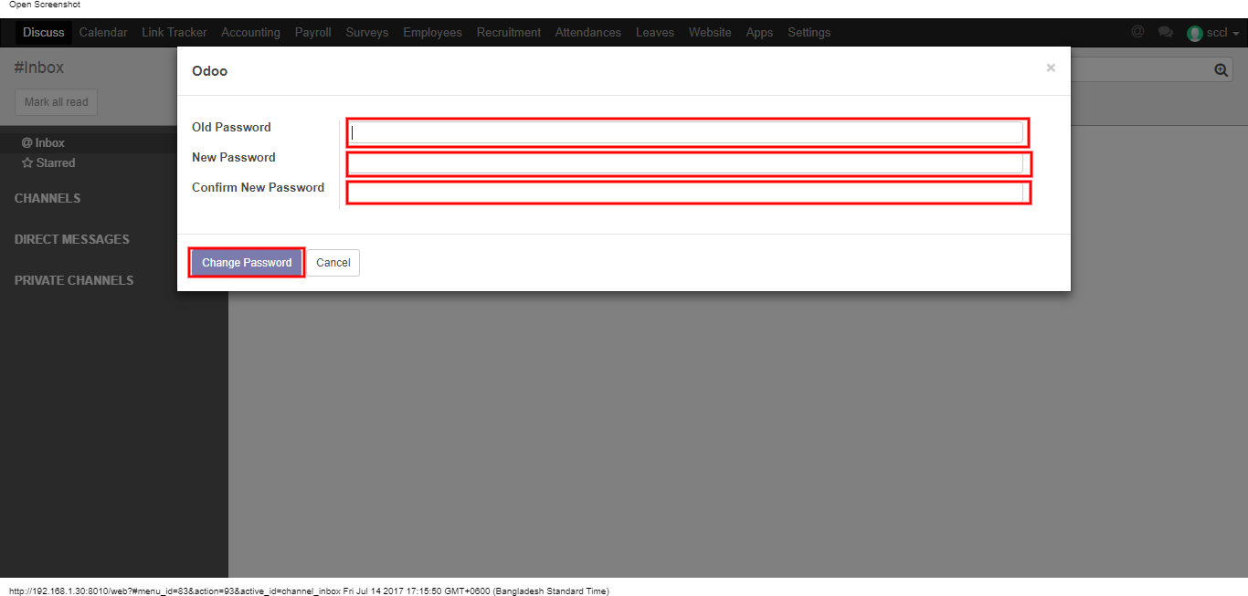

Fig: Change Password

## 1.5 Website Browse and Back to Home Page

Using the menu click **Website** and go to website page and to back click **Website button** then click any menu.

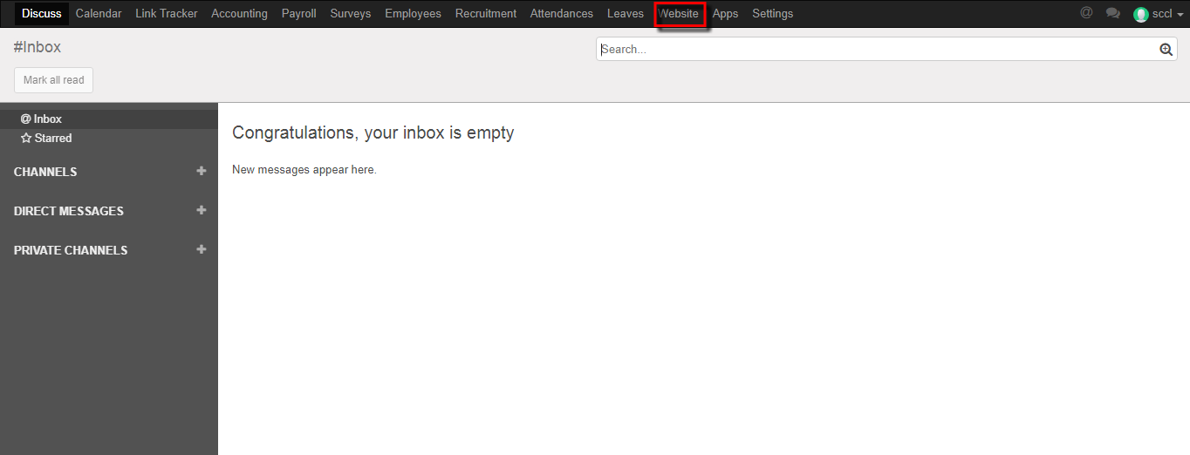

Fig: Go to Website Page

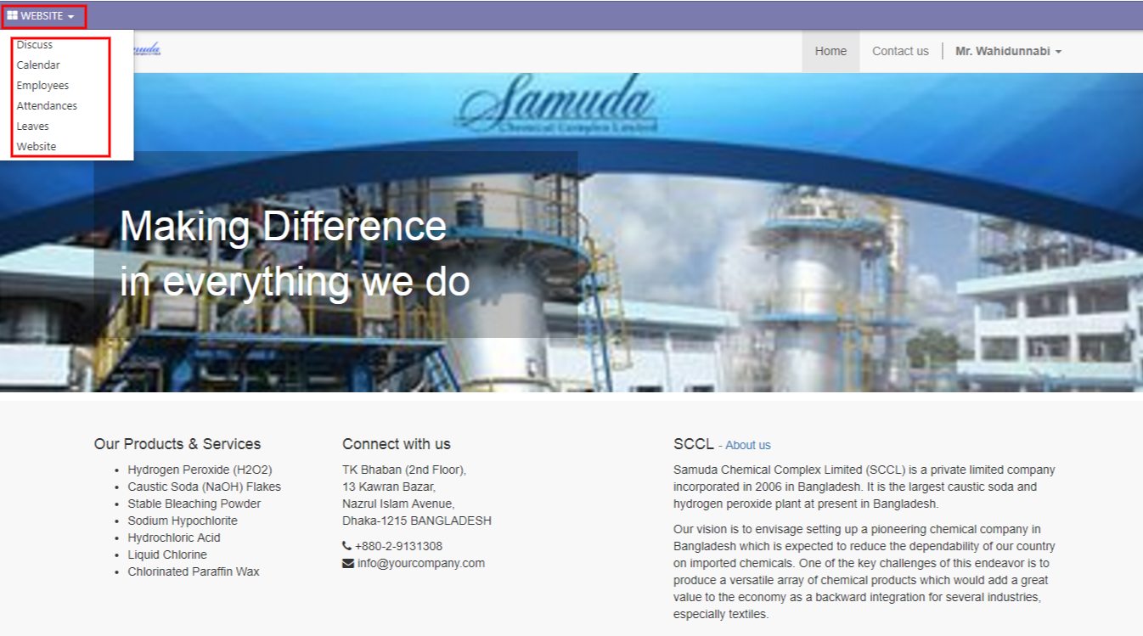

Fig: Back from Website Page

# 2. Leave Request

## 2.1 Create Leave Request

For create a leave request we have to go leave menu then create a leave request.

Using the menu **Leave ‣ My Leaves ‣ Leave Request** click **Calendar** button.

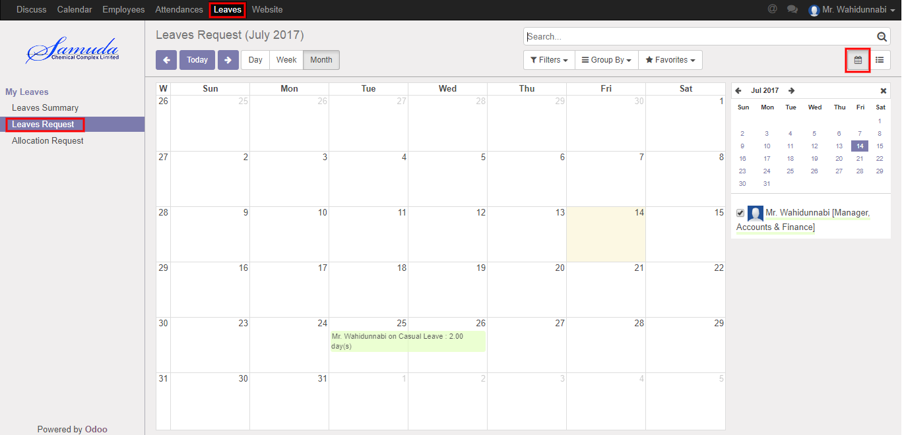

**Fig:** Leave Calendar View

Also we can see using the menu **Leave ‣ My Leaves ‣ Leave Request** click **List** button.

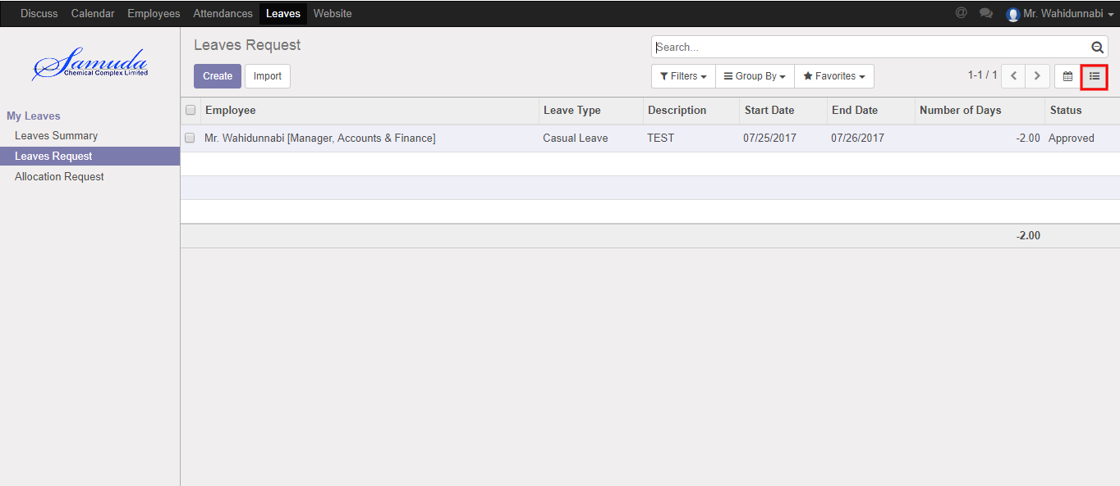

Figure**:** Leave List View

To create new Leave Request, Using the menu **Leave ‣ My Leaves ‣ Leave Request** click **Create**.

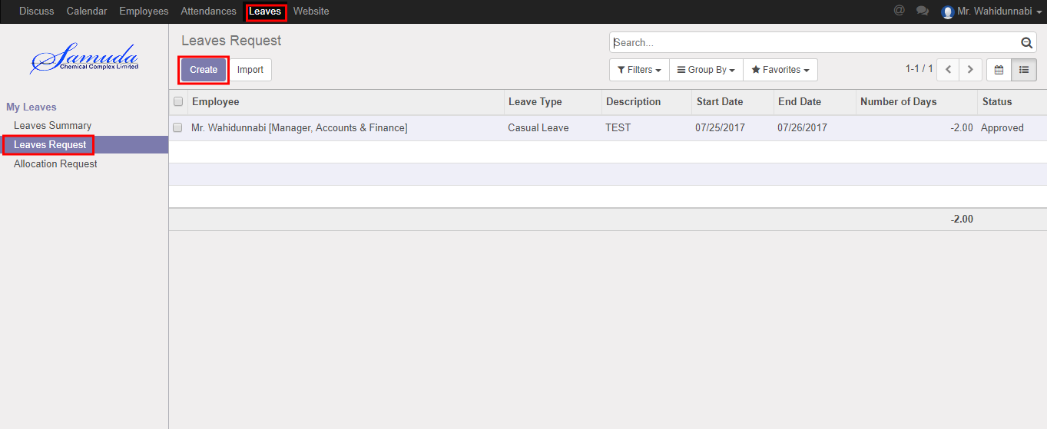

You can set the following information:-

**Description:** Enter some description.

**Leave Type:** Select a leave type.

**Duration:** Select duration of leave.

After entering the Leave Request information click **Save**.

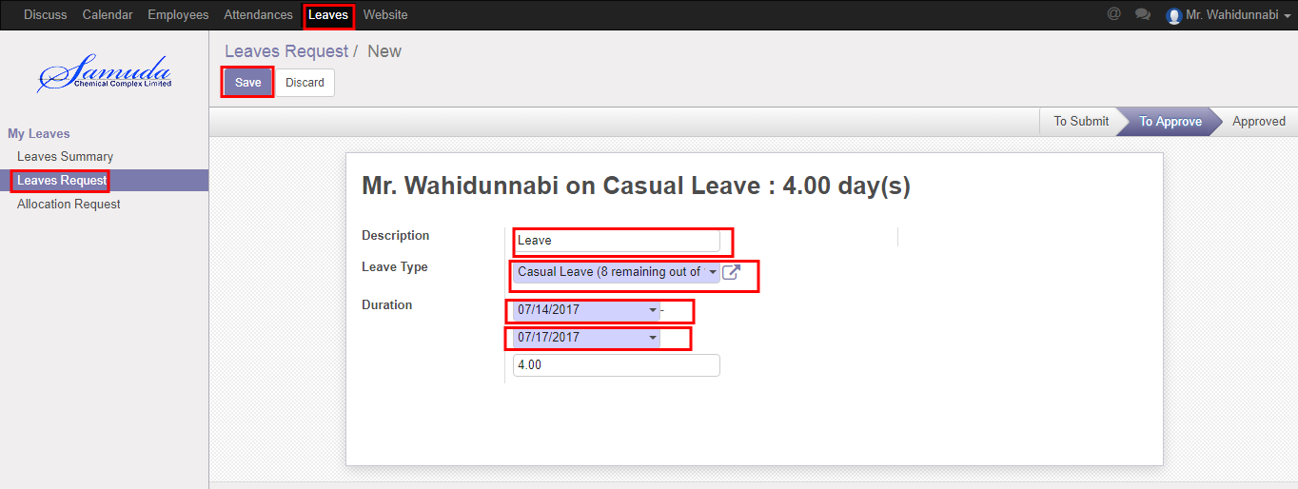

Figure: Create a Leave Request

After apply the leave request “Manager” will get the notification. Manager can approve the leave request. He can update number of leave day(s) before approval. After Manager Approval, HR will get notification. HR Manager Can Approve or Refuse the leave request. After that requested leave will finally approve.

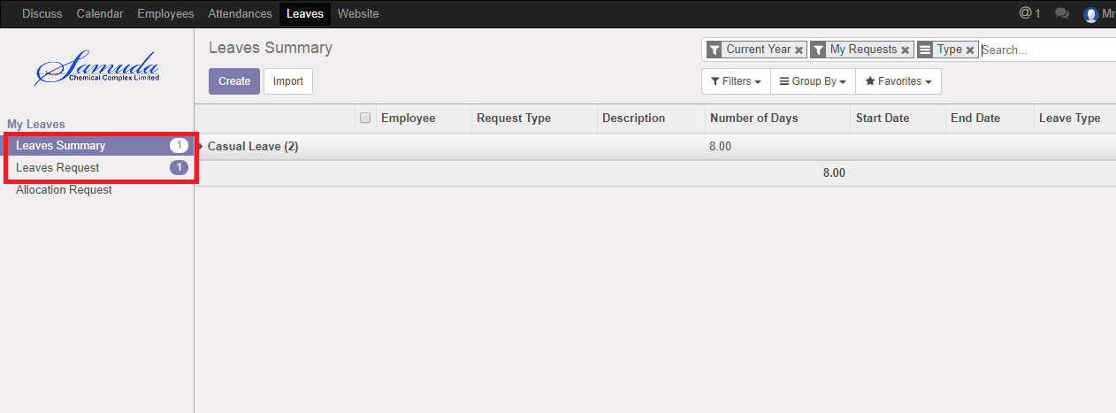

Figure: Leave Request Notification

## 2.2 Show Leave Summary

Using the menu **Leave ‣ My Leaves ‣ Leave Summary**.

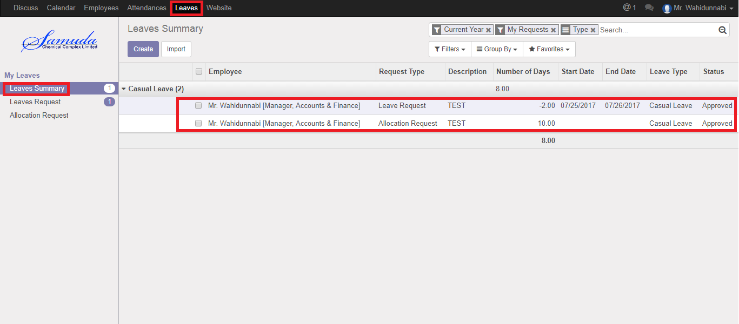

Figure: Leave Summary List View

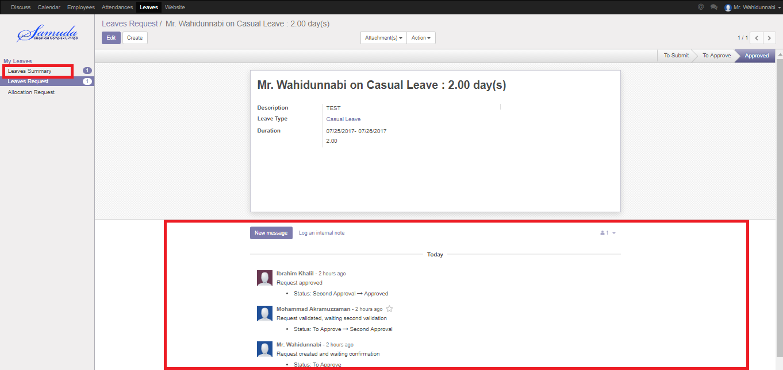

Figure: Leave Summary

## 2.3 Create Leave Allocation Request

For create a leave allocation request we have to go leave menu then create an allocation request.

Using the menu **Leave ‣ My Leaves ‣ Allocation Request** click **Create**.

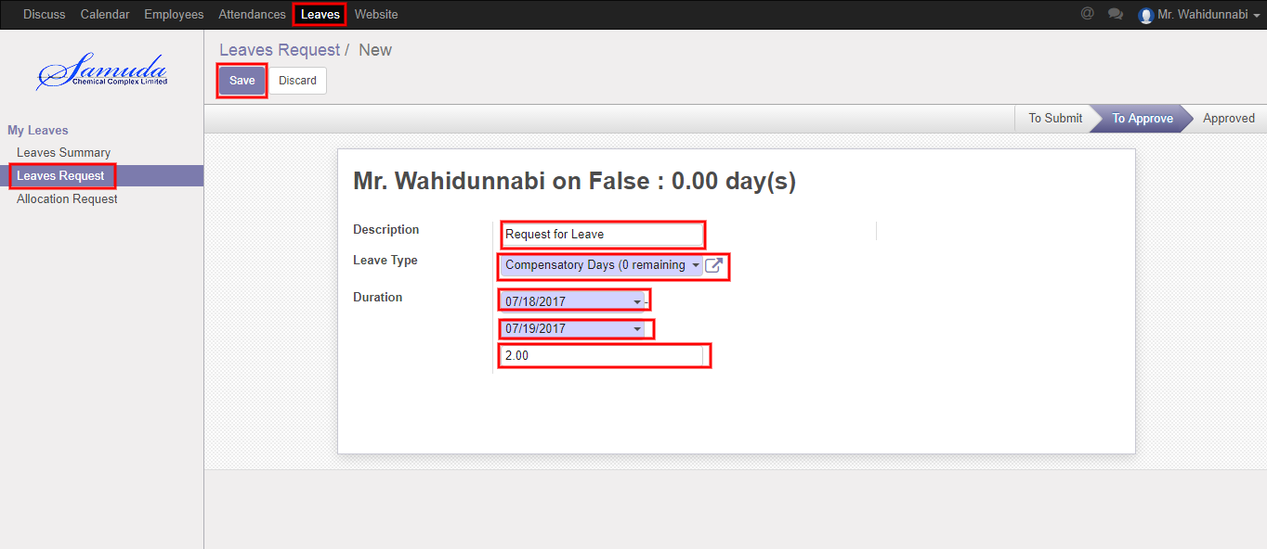

Figure: A Leave Allocation Request

After apply the leave allocation request “Manager” will get the notification. Manager can Approve or Refuse the leave allocation request. He can update number of day(s) before approval. After Manager Approval, HR will get notification. HR Manager Can Approve or Refuse the leave allocation request. After that requested leave allocation will finally approve.

# 3. Short Leave Request

## 2.1 Create Short Leave Request

Short Leave is for urgent private business that occurs without notice. Short leave can be used for an emergency purpose. For create a short leave request, we have to go **Leaves** menu then create a Short Leave Request.

To create new Short Leave Request, Using the menu **Leave ‣ Short Leaves ‣ Short Leaves** click **Create**.

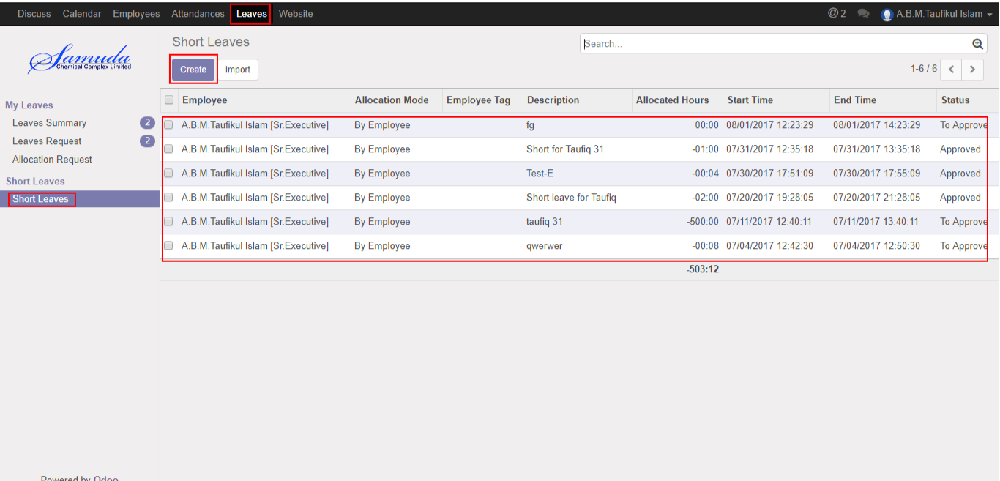

Figure: Short Leaves List View

You can set the following information:-

**Description:** Enter some description.

**Duration:** Select duration of leave.

After entering the Short Leave Request information click **Save**.

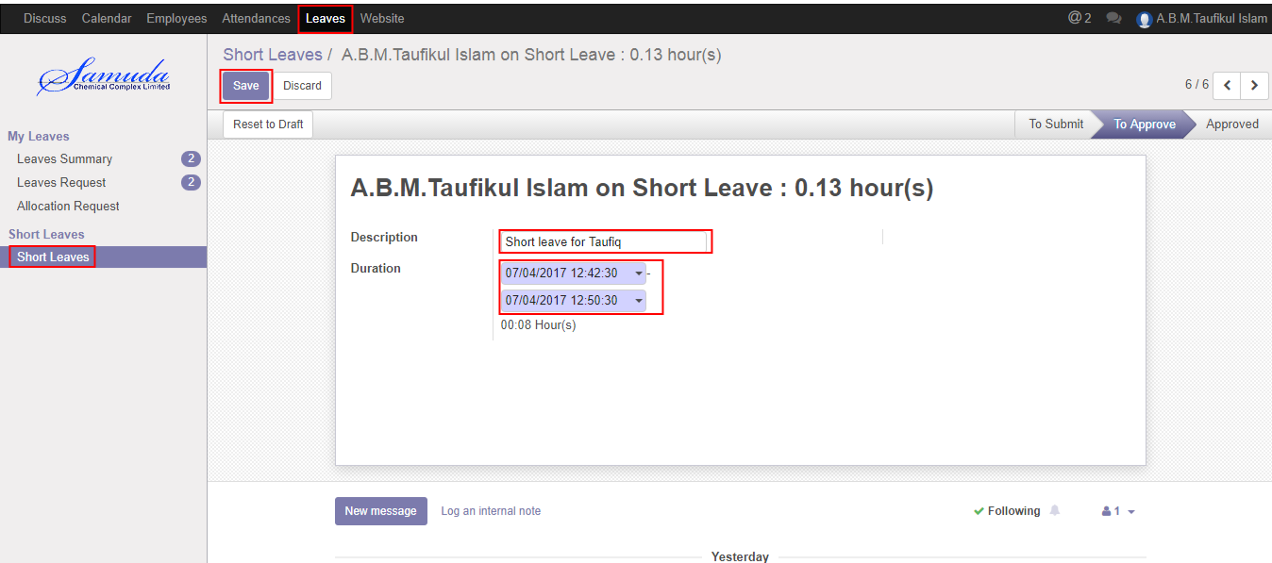

Figure: Create a Short Leave Request

After apply the short leave request Manager will see the request and Manager can Approve or Refuse the short leave request. After Manager Approval, HR will get notification. HR Manager Can Approve or Refuse the short leave request. After that requested short leave will finally approve.

# 4. Attendance

## 4.1 Create Manual Attendance

Sometimes employees work outside of office for this reason he/her can’t sign in or sign out. To solve this problem employee can request to HR Manager by this manual attendance process.

We can create manual attendance using the menu **Attendances ‣ Manual Attendances ‣ My Attendances** and click **Create.**

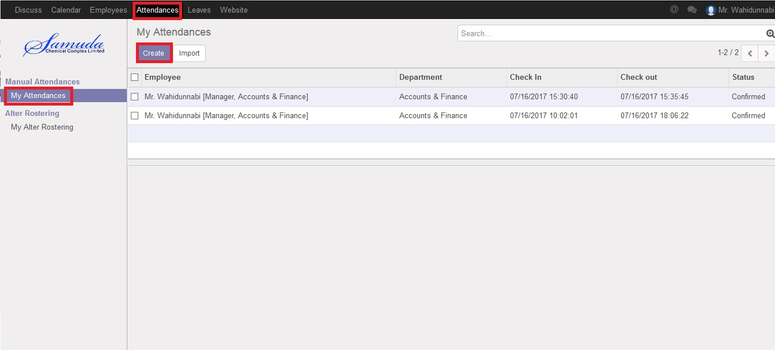

Figure: Manual Attendance List view

We need to set the following:-

**Employee**: An employee name.

**Department**: Select a department.

**Sign Type:** Select a sign type.

**Check In:** Work starting time.

**Check Out:** Work closing time.

After entering all information click **Save**.

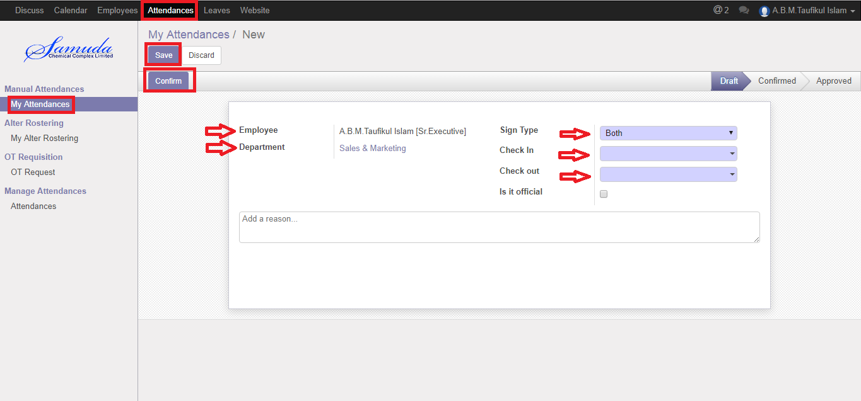

Figure: Create a Manual Attendance

## 4.2 Create Alter Rostering

Sometimes employees want to change his/her shifting and they want to request HR Manager. For solving this problem employee can request to HR Manager by this Alter Rostering process.

We can create alter rostering using the menu **Attendances ‣ Alter Rostering ‣ My Alter Rostering** click **Create.**

You need to set the following:-

**Employee**: An employee name.

**Alter Date:** A date for attendance.

**Duty Start:** A work stating time.

**Duty End:** A work closing time.

**OT Start:** A work over stating time.

**OT End:** A work over closing time.

After entering the alter rostering information click **Save**.

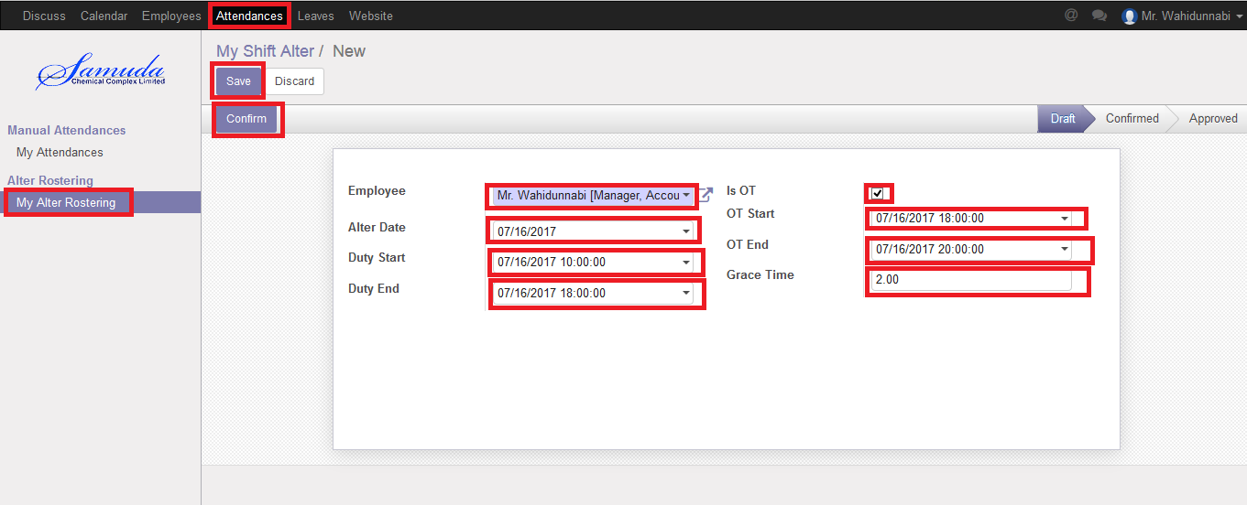

Figure: Create a Alter Rostering

After apply the Alter Rostering request HR Manager will see the request on Alter Rostering menu. HR Manager can approve or refuse the Alter Rostering request. After that requested Alter Rostering will finally approve. After final approval user can see on my Alter Rostering menu.

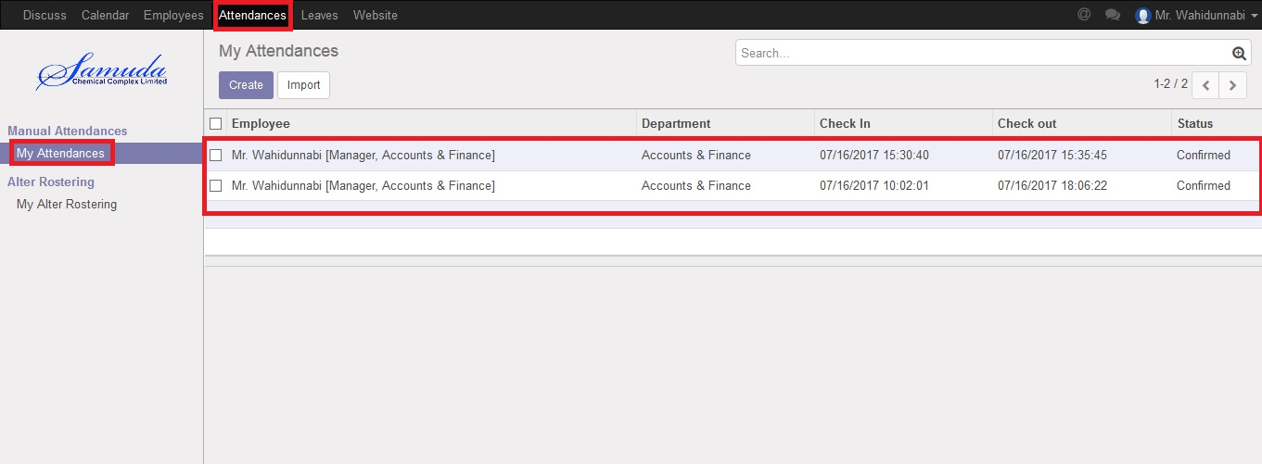

Figure: Alter Rostering Status

# 5. OT Requisition

## 5.1 Create a OT Request

Sometimes employees want to extra overtime work that’s why he/she have to request Manager. To solve this problem employee can request to Manager by this OT Requisition process.

We can create OT Request using the menu **Attendances ‣ OT Requisition ‣ OT Request** and click **Create.**

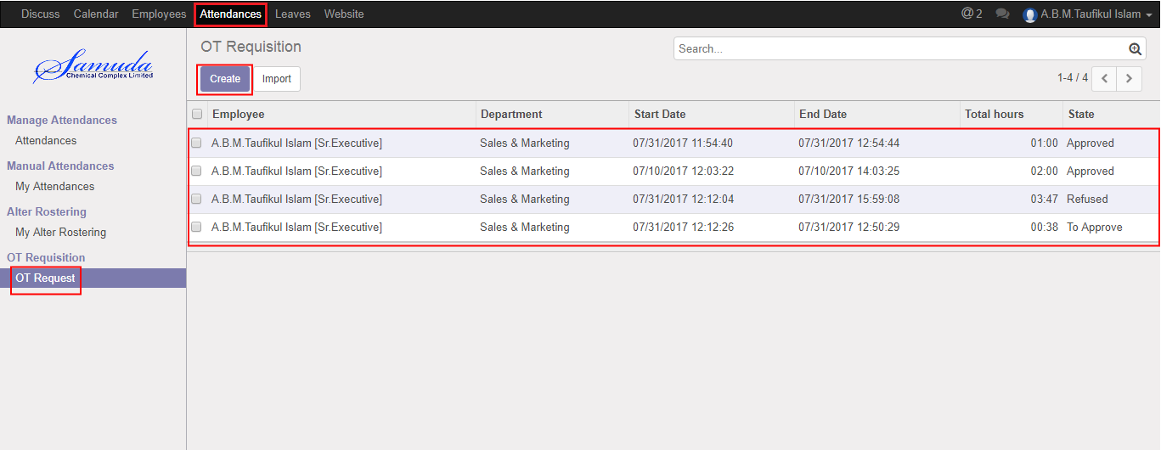

Figure: OT Request List view

We need to set the following:-

**Employee**: An employee name.

**Department**: Automatically select a department.

**Start Date:** Work starting time.

**End Date:** Work closing time.

After entering all information click **Save**.

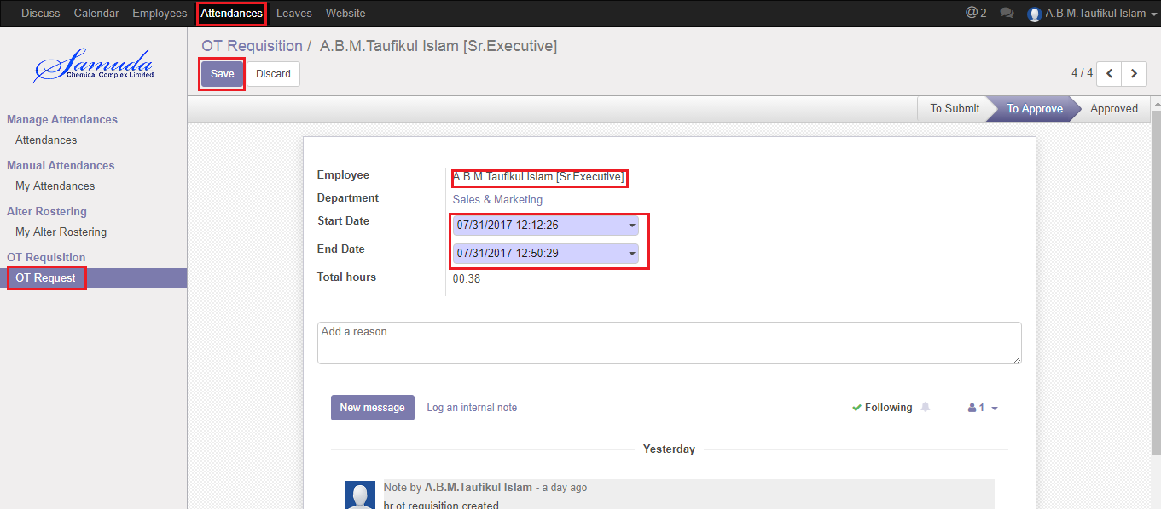

Figure: Create a OT Request